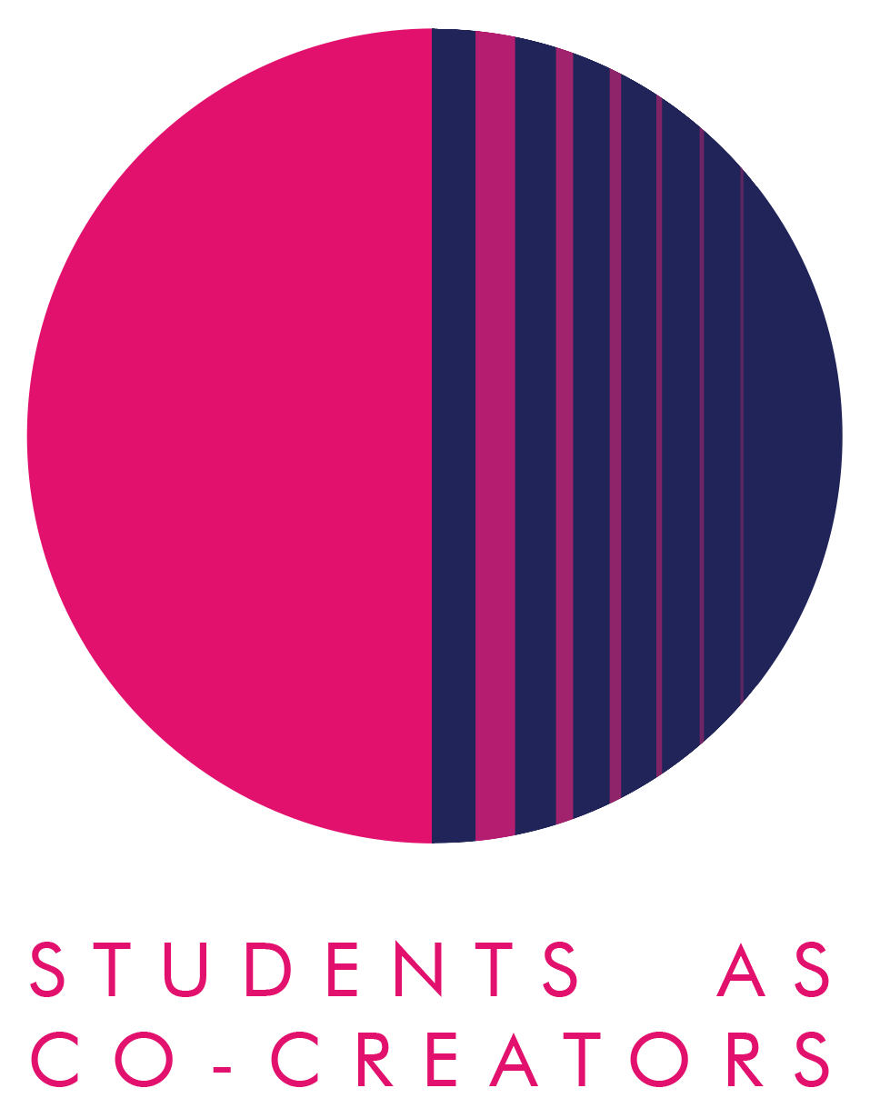
Students as Co-Creators LTRC Project Application Form

Thank you for considering applying for a Students as Co-Creators project. Please answer all of the questions in the form and email it to studentpartnership@westminster.ac.uk by 12noon, 3rd November 2021 for cycle 1 or 16th February for cycle 2.

Project Title:

Project Team

 | Name | Email | College/School & level of study
Student Partner 1
Student Partner 2
Student Partner 3

Student Partner 4
Student Partner 5

 | Name | Email | College/School
Academic Partner 1
Academic Partner 2

Academic Partner 3

Declaration by team (signed by the academic partner on behalf of the team):
- We hereby confirm that upon acceptance of our application, we will submit a budget application, ethics application as and if required, a project evaluation report and individual reflective reports.
- We acknowledge that if students do not provide all information necessary for the bursary payment, then the payment cannot be done.

Signature:-----------------------------------
Name and Date:---------------------------

- Research Topic

- What is your research question? Be specific and write this as a question. Your answer may include more than one question. (100-150 words)

- What are the aims of your research? Tell us specifically what your team wishes to discover in the process of undertaking the project. (150-250 words)

- Research Impact

- Why is this research project important for you and other students at Westminster? (150-250 words)

- How do you propose to communicate the outcomes of your project (e.g. blogs, websites, posters, booklet, video, podcast) and share your final findings?

- Describe the key methodologies you will use to achieve the aims of your research. Tell us specifically how your team will find answers to your research questions. (150-250 words)

- Project Management

- Please confirm a team meeting has taken place with all the Partners listed on this application form to discuss the project and the application, and that you have all referred to the ‘Westminster Co-Creators Principles’. List the names of those present at the meeting and the date of the meeting:

- How will the Partners in your team communicate to manage the project and share its workload? (100-150 words)

Next Steps and Key Dates
A student and staff selection panel will meet to assess the applications. You will receive the outcome of your application via email by the 12th of November 2021 for cycle 1 and 25th February 2022 for cycle 1. If your application is successful, your team will be required to attend a mandatory introduction workshop. Below are all the key dates and timings you need to keep in your diaries:
Project timelines for 2021/22 cycles 1 and 2

Timeline for cycle 1:

Timeline for cycle 2:

For further information and guidance on completing your project submission please contact:
Dr Fatima Maatwk
Student Partnership Lecturer, Centre for Education and Teaching Innovation, studentpartnership@westminster.ac.uk

