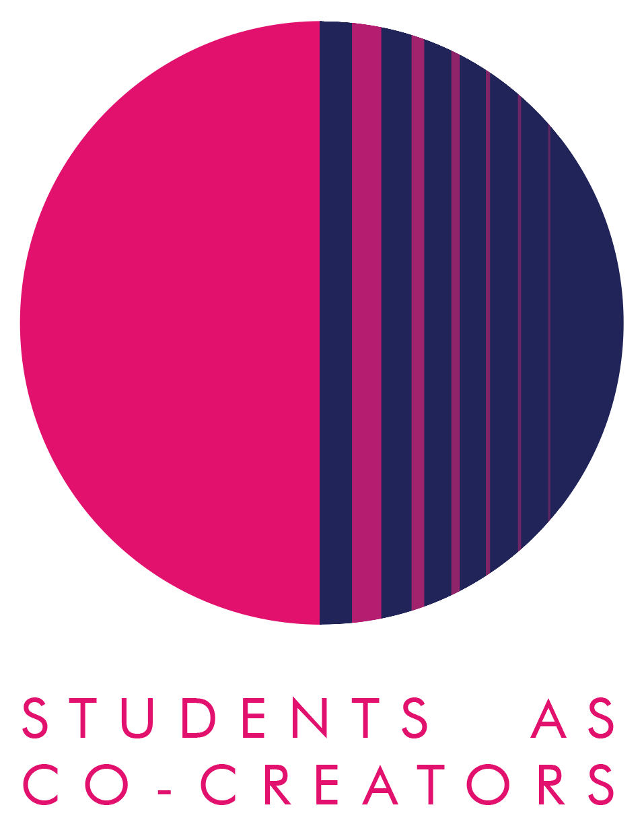
Students as Co-Creators Disciplinary Research Collaborations (DRC) Application Form

Thank you for considering applying for a Students as Co-Creators project. Please answer all the questions in the form and email it to studentpartnership@westminster.ac.uk by 12noon, 3rd November 2021 for cycle 1 or 16th February for cycle 2.

Project Title:

Project Team

 | Name | Email | College/School & level of study
Student Partner 1
Student Partner 2
Student Partner 3

Student Partner 4
Student Partner 5

 | Name | Email | College/School
Academic Partner 1
Academic Partner 2

Academic Partner 3

Declaration by team (signed by the academic partner on behalf of the team):
- We hereby confirm that upon acceptance of our application, we will submit a budget application, ethics application as and if required, a project evaluation report and individual reflective reports.
- We acknowledge that if students do not provide all information necessary for the bursary payment, then the payment cannot be done.

Signature:-----------------------------------
Name and Date:---------------------------

1) Research Topic

- What is your research question? Be specific and write this as a question. Your answer may include more than one question.

- What are the aims of your research? Tell us specifically what your team wishes to discover in the process of undertaking the project. (100-150 words)

- Describe the key methodologies you will use to achieve the aims of your research. Tell us specifically how your team will find answers to your research questions. (150-250 words
2) Research Impact

- Why is this research project important for the group’s participants? (150-250 words)

- How do you propose to communicate the outcomes of your project (e.g. blogs, websites, posters, booklet, video, podcast) and share your final findings?

3) Project Management

- Please explain how you plan to work together as a group in partnership? You may wish to consult the Westminster Partnership Principles available here, for ideas on how to approach this. (150-200 words)

- How will the Partners in your team communicate to manage the project and share its workload? (100-150 words)

Next Steps and Key Dates
A student and staff selection panel will meet to assess the applications. You will receive the outcome of your application via email by the 12th of November 2021 for cycle 1 and 25th February 2022 for cycle 1. If your application is successful, your team will be required to attend a mandatory introduction workshop. Below are all the key dates and timings you need to keep in your diaries:
Project timelines for 2021/22 cycles 1 and 2

Timeline for cycle 1:

Timeline for cycle 2:

For further information and guidance on completing your project submission please contact:
Dr Fatima Maatwk
Student Partnership Lecturer, Centre for Education and Teaching Innovation, studentpartnership@westminster.ac.uk

