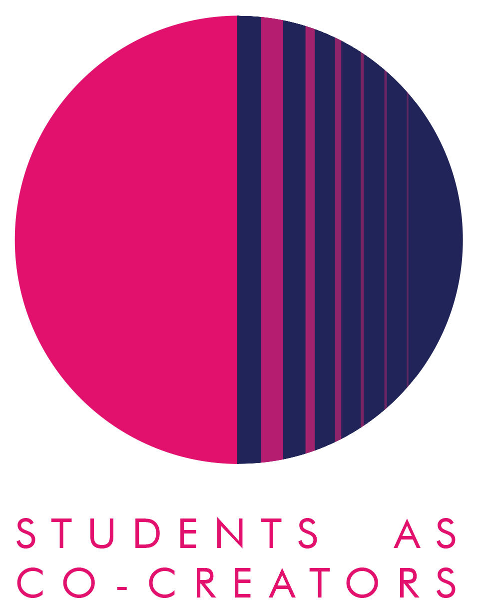
Students as Co-Creators Curriculum Design Collaborations (CDC) Application Form

The CDC strand of the Students as Co-Creators programme enables staff to work in partnership with students to review and develop an aspect of their course or module. Examples include:

- Learning materials
- Assessment guidelines
- Syllabus or assessment content
- Teaching style
- Blackboard
- Handbooks

We welcome all members of staff to apply for a CDC Students as Co-Creators project and recommend them to form a team with students prior to submitting an application. If staff are unable to recruit students, then the SCC team can try and pair members of staff with students from the Foundation years and above.

Thank you for considering applying for a Students as Co-Creators project. Please fill out the below details on student and academic partners, answer all the questions in the form and email it to studentpartnership@westminster.ac.uk by 12noon, 3rd November 2021 for cycle 1 or 16th February for cycle 2. Please refer to the Westminster Co-Creators Principles before you apply.

Declaration by team (signed by the academic partner on behalf of the team):
- We hereby confirm that upon acceptance of our application, we will submit a budget application, ethics application as and if required, a project evaluation report and individual reflective reports.
- We acknowledge that if students do not provide all information necessary for the bursary payment, then the payment cannot be done.

Signature:-----------------------------------
Name and Date:---------------------------
Project Title:

The Project Team:

 | Name | Email | College/School
Academic Partner 1
Academic Partner 2

Academic Partner 3

If you have confirmed with students that they would like to work in partnership with you, please provide their details:

 | Name | Email | College/School & level of study
Student Partner 1
Student Partner 2
Student Partner 3

Student Partner 4
Student Partner 5

- Which area of your curriculum are you interested in reviewing and/or developing? Please tell us what you think will be involved in undertaking this review (200-300 words)

- Why do you want this review and/or development to take place in partnership with students? (250-350 words)

- How do you propose to undertake this review and/or development? Please describe how you want to work with students. (250-350 words)

Next Steps and Key Dates
A student and staff selection panel will meet to assess the applications. You will receive the outcome of your application via email by the 12th of November 2021 for cycle 1 and 25th February 2022 for cycle 1. If your application is successful, your team will be required to attend a mandatory introduction workshop. Below are all the key dates and timings you need to keep in your diaries:
Project timelines for 2021/22 cycles 1 and 2

Timeline for cycle 1:

Timeline for cycle 2:

For further information and guidance on completing your project submission please contact:
Dr Fatima Maatwk
Student Partnership Lecturer, Centre for Education and Teaching Innovation, studentpartnership@westminster.ac.uk

