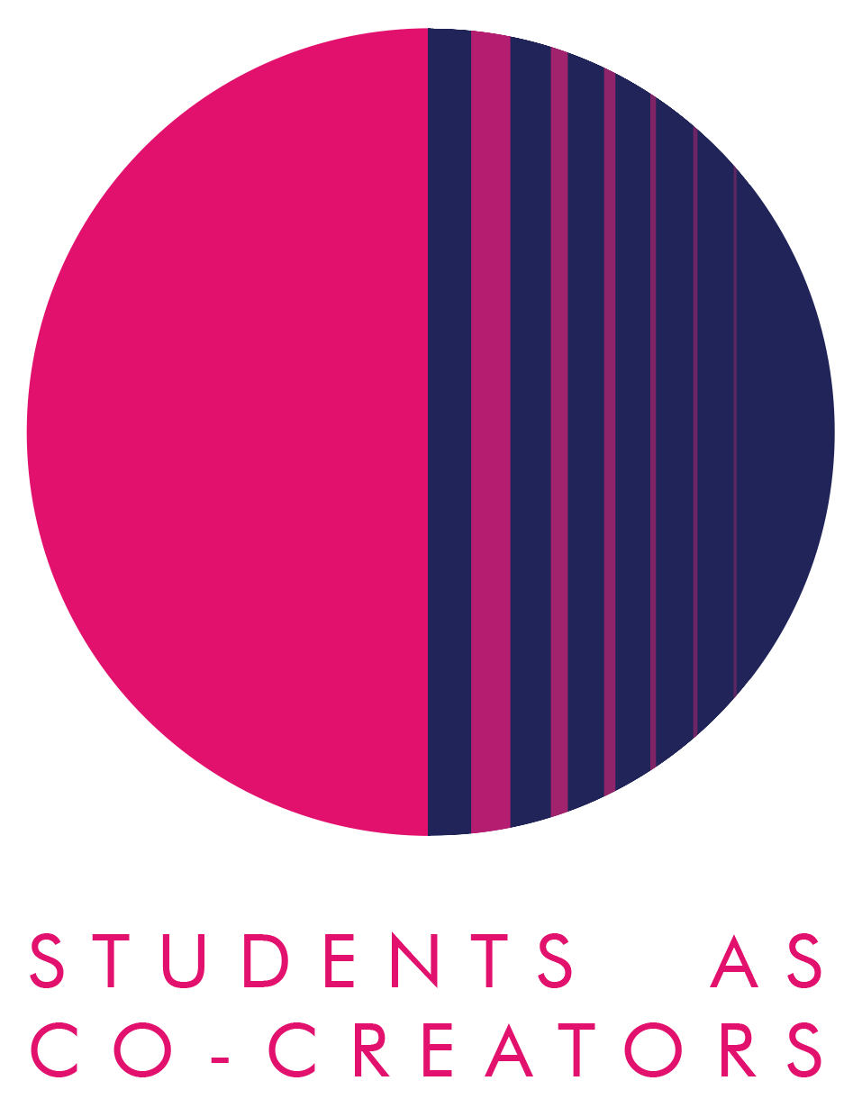
Students as Co-Creators LTRC Project Application Form

Thank you for considering applying for a Students as Co-Creators project. Please answer all of the questions in the form and email it to studentpartnership@westminster.ac.uk by 12pm, 10th February 2021.

Project Title:

- The Project Team

 | Name | Email | College/School & level of study
Student Partner 1
Student Partner 2
Student Partner 3

Student Partner 4
Student Partner 5

 | Name | Email | College/School
Academic Partner 1
Academic Partner 2

Academic Partner 3

- Research Topic

- What is your research question? Be specific and write this as a question. Your answer may include more than one question.

- What are the aims of your research? Tell us specifically what your team wishes to discover in the process of undertaking the project.

- Research Impact

- Why is this research project important for you and other students at Westminster?

- How do you propose to communicate the outcomes of your project (e.g. blogs, websites, posters, booklet, video, podcast) and share your final findings?

- Describe the key methodologies you will use to achieve the aims of your research. Tell us specifically how your team will find answers to your research questions.

- Project Management

- Please confirm a team meeting has taken place with all the Partners listed on this application form to discuss the project and the application, and that you have all referred to the ‘Westminster Co-Creators Principles’. List the names of those present at the meeting and the date of the meeting:

- How will the Partners in your team communicate to manage the project and share its workload?

Next Steps
A student and staff selection panel will meet to assess the applications. You will receive the outcome of your application via email by the 19th of February 2021. If your application is successful, your team will be required to attend a mandatory introduction workshop. Here are all the key dates and timings:
Project Timelines

For further information and guidance on completing your project submission please contact:
Dr Fatima Maatwk
Student Partnership Lecturer, Centre for Education and Teaching Innovation, studentpartnership@westminster.ac.uk

