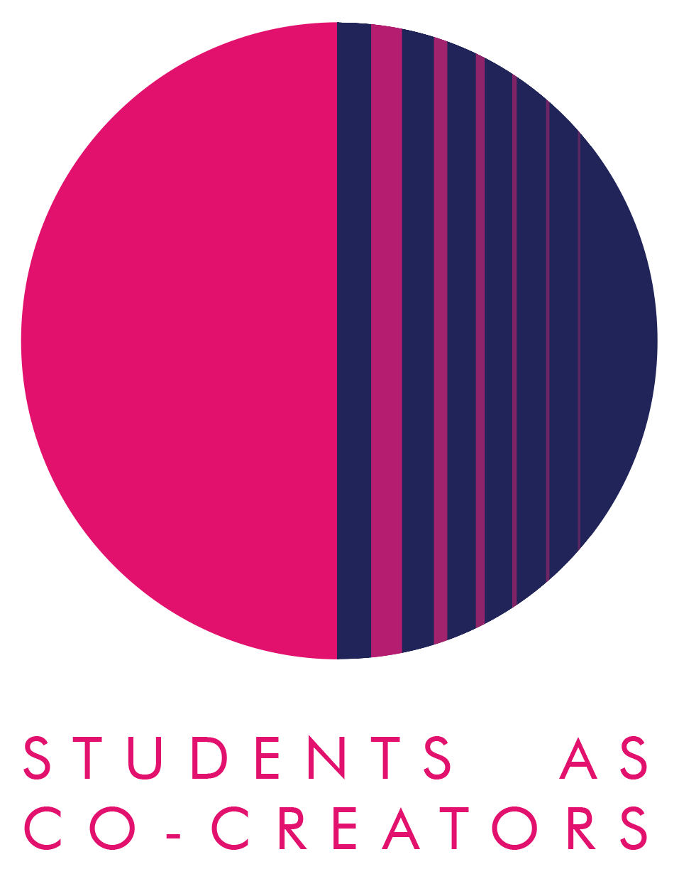
Students as Co-Creators Curriculum Design Collaborations (CDC) Application Form

The CDC strand of the Students as Co-Creators programme enables staff to work in partnership with students to review and develop an aspect of their course or module. Examples include:
- Learning materials
- Assessment guidelines
- Syllabus or assessment content
- Teaching style
- Blackboard
- Handbooks

We welcome all members of staff to apply for a CDC Students as Co-Creators project and recommend them to form a team with students prior to submitting an application. If staff are unable to recruit students, then the SCC team can try and pair members of staff with students from the Foundation years and above.

Thank you for considering applying for a Students as Co-Creators project. Please fill out the below details on student and academic partners, answer all of the questions in the form and email it to studentpartnership@westminster.ac.uk by 12pm, 10th February 2021. Please refer to the Westminster Co-Creators Principles before you apply.

Project Title:

The Project Team:

 | Name | Email | College/School
Academic Partner 1
Academic Partner 2

Academic Partner 3

If you have confirmed with students that they would like to work in partnership with you, please provide their details:

 | Name | Email | College/School & level of study
Student Partner 1
Student Partner 2
Student Partner 3

Student Partner 4
Student Partner 5

- Which area of your curriculum are you interested in reviewing and/or developing? Please tell us what you think will be involved in undertaking this review.

- Why do you want this review and/or development to take place in partnership with students?

- How do you propose to undertake this review and/or development? Please describe how you want to work with students.

Next Steps
A student and staff selection panel will meet to assess the applications. You will receive the outcome of your application via email by the 19th of February 2021. If your application is successful, your team will be required to attend a mandatory introduction workshop. Here are all the key dates and timings:
Project Timelines

For further information and guidance on completing your project submission please contact:
Dr Fatima Maatwk
Student Partnership Lecturer, Centre for Education and Teaching Innovation, studentpartnership@westminster.ac.uk

