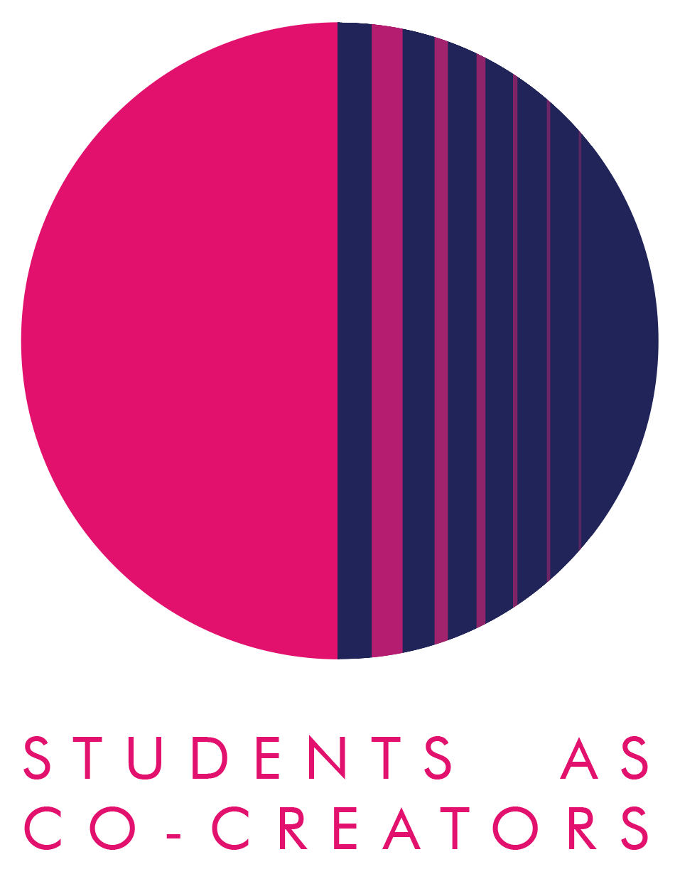
Students as Co-Creators Curriculum Design Collaborations (CDC) Application Form

The CDC strand of the Students as Co-Creators programme enables staff to work in partnership with students to develop an aspect of their course or module. Examples include:
- Learning materials
- Assessment guidelines
- Syllabus or assessment content
- Teaching style
- Blackboard
- Handbooks

With this special call for applications we are prioritising projects that engage in some form with the move to online learning.

We welcome all members of staff to apply for a CDC Students as Co-Creators project and recommend forming a team with students prior to submitting an application.

To apply, please answer all of the questions below and email the form to studentpartnership@westminster.ac.uk. You should also include a project budget application along with this application (available with same email as this application form or by emailing studentpartnership@westminster.ac.uk). This special call for CDC projects (Online Learning) will operate a rolling deadline from 13th July 2020 to 11th December 2020, as funds permit. Please refer to the Westminster Co-Creators Principles before you apply (also attached to this email).

Name
Email
College and School

- Which area of your curriculum are you interested in addressing? Please tell us what you think will be involved in undertaking this project.

- Why do you want this project to take place in partnership with students?

- How do you propose to undertake this project? Please describe how you want to work with students.

If you have confirmed with students that they would like to work in partnership with you, please provide their details:

Student Name
Student Email
College/School

Please note that each student involved in the project will receive a bursary of £100 for their participation. You may have up to five students per project.
Next Steps
A student and staff selection panel will meet to assess the applications. You should receive the outcome of your application via email within two weeks. Once your application is successful, we will enrol you on the Students as Co-Creators Blackboard organisation. This will provide you with additional information and support throughout the project.
**If an ethics application is considered necessary by the selection panel, this may be submitted to the relevant School ethics committee or CETI ethics committee.**
For further information and guidance on completing your application form please contact: Dr Jennifer Fraser, University Director of Student Partnership, Centre for Education and Teaching Innovation, studentpartnership@westminster.ac.uk

