Students as Co-Creators LTRC Project Evaluation Report

Project Title: Metacampus Virtual Tour

Research Team:

Student Partners: Alexandru Mondan &
Michal Dioszegi

Academic Partner: Jeffrey Ferguson

School of Computer Sciences

Academic Year 2018-2019

Executive Summary

Video Link: https://drive.google.com/file/d/1wPHDEM7RgIGRAMMEfcofi06qyXCKFWck/view

MetaCampus Virtual Tour is an SCC project that allows both provisional, current, and alumni students and University Of Westminster staff members to have a better view of what our university has to offer, to easily discover useful information about the classrooms or laboratories and to get the full usability of the on-site services.
This project enables the user to visit the University Of Westminster Cavendish campus at the moment and further versions will provide for other campuses as well. MetaCampus has two versions: the web browser version and the Virtual Reality version. The browser version uses WebGL so it can be used on all web browsers and the University Of Westminster site in order to be easily accessed by multiple devices. The Virtual Reality version needs a VR Headset in order to run and it offers the full experience of a Open Day tour. This virtual tour uses point-to-point views just like on Google Maps that allows the user to have a realistic experience by exploring the actual layout of the building. In every classroom there are User Interface Elements that provide useful information about the working space and services such as booking the room, printing portal or logging a maintenance request. As well this virtual tour helps overseas provisional students to have a better view of the university’s facilities.
When it comes to who benefits from this project it is a win-win for everyone from students to staff members. The provisional students that cannot attend open days are offered a virtual tour with accurate and updated information in a very interactive and responsive way. The students and staff members can easily locate and book rooms inside campus and check if the room provide enough resources (computer specifications, slots, who can access the room) for their needs. Last but not least, the maintenance system will help to easily log a call and locate any problem so the staff members can work more efficiently and the feedback system will help the university understand the students needs.
Working on this environment to build the project always create challenges. We are developing this project to be very responsive and less resource consuming without altering the quality of the services offered. In this way the next steps are optimization, increasing the security level and enhancing the user interface together with adding other useful services. At present we are in discussions with the University to host this on the official website.

Section 2. Background and Aims
Background:
Our project idea came as a response to a problem that every university faces in the current global market environment. Provisional students need to efficiently access information about their desired university in order to make a choice even if they live in far-flung destinations. Our idea is to not only offer a campus tour, thus we offer a experience for getting in depth knowledge about how to develop in our Cavendish Campus.

Aims:
The aim is to improve current and prospective student experience, as well as University reputation, by offering an online virtual campus in 360 images. This has a huge impact on current students and lecturers, as well as the general public, by enabling them to explore our facilities and demonstrate what Cavendish campus has to offer in a very intuitive and user friendly interface on a public platform. This project contributes to an outstanding student experience in navigating physical spaces digitally. It will enhance university reputation and profile as it is to be published on the XRlab site. As our university is diverse, delivering a project that offers virtual tours and presentations of the university features is expected to increase the accessibility for the overseas students and staff.

Objectives:
In order to create the Virtual Tour we successfully mapped the Campus using a high quality 360 degree camera and then we used the images in our Meta Campus Unity3D project to create the virtual environment compatible with websites. The user interface has been created with the help of Unity Tools together with the University Of Westminster Style Guide. All the functionality was created from scratch using C#, PHP and SQL with knowledge gained from individual research and with the database module notes for the SQL part.

The feedback system is actively registering data from anonymous users that explore the virtual tour and if they want to suggest us something or to report a bug they can send us their thoughts using the built in feedback system. We store all the feedback data in a MySQL database.

Stakeholders:
Our research offers a tool that both academics and students can actively use. The functionality present and in development in our virtual tour enables provisional students to wisely choose a course at our university by enabling them to explore and see the on-campus services and equipment. . The students and staff members can easily locate, identify, and book rooms inside campus and check if the room provide enough resources (computer specifications, slots, who can access the room) for their needs. Last but not least, the maintenance system will help to easily log a call and locate any problem so the staff members can work more efficiently and the feedback system will help the university understand the students needs.

Section 3. Methods
During the development of our project we were always seeking for feedback. In this way we invited both provisional, actual, and alumni students together with academics to take part in our presentations and to test the product. During every session we analysed how people reacted at different points of the virtual tour and we modified different aspects in order to provide a comfortable experience. After the sessions we received direct feedback and suggestions that we considered for further development. As well, after the deployment of the product we will continuously receive feedback in our database which will help us to find bugs and to enhance the experience.
We considered many ethical issues, one of which is data protection. All the users will explore the virtual tour anonymously via randomised number logins. As a result of this, the survey database only collects anonymised data.
Once the tour development is finished from a technical standpoint, we can have a final survey that collects qualitative feedback from the likert scales that are presented to users before they can proceed to the next area of the University tour.

Section 4. Results
There is a qualitative survey based on completing the tour. As the tour is currently undergoing troubleshooting, we will complete the needed optimisation before presenting it to groups for feedback.

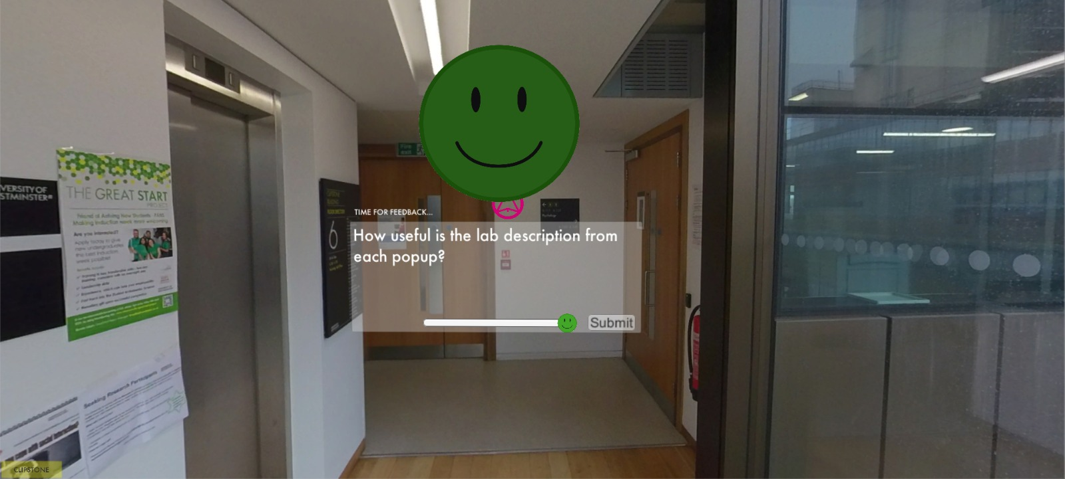
There are questions with Likert scale feedback placed at the junctions between areas in the tour
(usually separate floors) . These are saved into an SQL database for analysis. The data is naturally anonymous, and will provide a qualitative overview of the tour’s success.

Section 5. Discussion

The outcome in our case is a product that uses two main parts: the WebGL build that is basically the engine of our virtual tour and the hosted assets. The most important functionality related scripts and assets are saved in the WebGL build, meanwhile the 360 degree images, the scenes and the other specific functions are hosted on servers. In this way we made our product able to work on websites, further optimisation will make it compatible with mobile devices and low specification computers.
Thanks to the used methods we are enhancing the virtual tour. The positive feedback from all the participants has determined us to register progress and the lack of knowledge that we had determined us to research more and more.

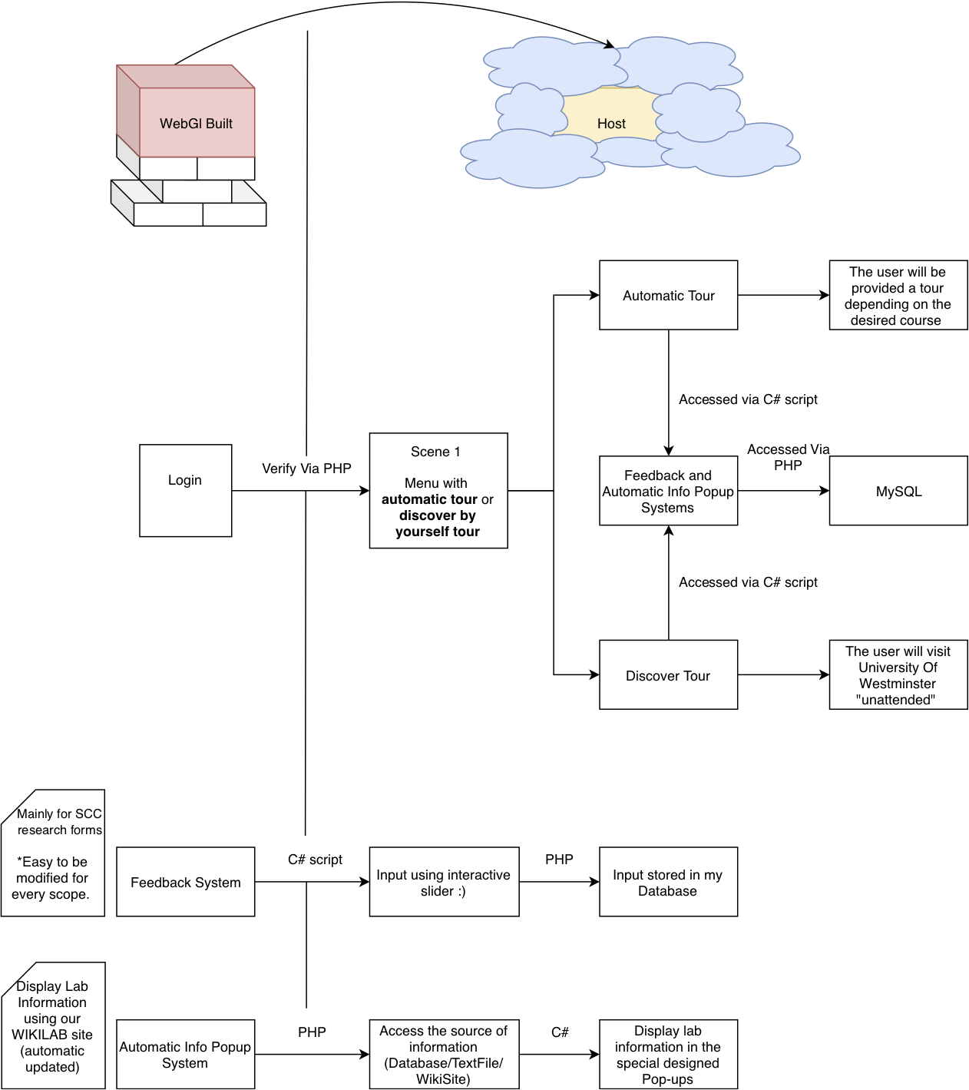
By working on this project we consider that the real outcome is more than just our virtual tour, now we gained experience in team-working, resource finding, developing ideas and presenting our work. This experience will definitely make us stand out in future interviews, positions, and client project work.

Section 6. Conclusions and Recommendations
This Students as Co-Creators project is standing out as it is the development of a software meant to improve the student experience , to advertise the campus services, to help with campus maintenance in an immersive experience. All of these attributes were developed in after analysing the feedback and suggestions from both students and academics together with our own perspective. We know that our university will hugely benefit from the virtual tour as its functions target is both provisional, actual and alumni students, academics and staff.
One problem is optimisation in the current web environment, we are continuously researching and trying different methods to optimise our product in order to work very fast and with very less loading time.
The main unexpected problem is that the size of this project is unsupported by browsers. We developed a a few solutions that seem to work, but only on computers and laptops. Further technologies will make it available for every device, this is why we are continuously adapting our program and testing it periodically.

Section 7. Dissemination
This product is meant to raise interest among the heads of the University Of Westminster in order to get enough support and approval to link our functions with the main website, leading to further development and to continue to to capture the other campuses.
As a final product we found out that more people are interested in different aspects of this virtual tour. Depending on the targeted users we are offering different functionality. For example, provisional and actual students want to know more about the on-campus services and features, meanwhile the technical staff is interested in the accurate layout of the rooms and what is inside. As well the feedback system will record other suggestions in order to improve or fix our program.
We are currently in discussion with Suvi Streatfield, Head of Digital for the University, in order to finalise plans to incorporate the tour into the official website.

Section 8. Reflection
While coordinating this research we found out how our idea evolved in an actual product that is just a few steps away from deployment. Our project has a few characteristics that creates problems. The first problem was to get all the pictures in almost the same weather conditions as the capturing process is very time consuming and we could capture only one floor a day depending on the courses that were going on at the spot, how clean were the rooms and what is the weather outside. Another problem was to get access to different rooms. Moreover the biggest problem was to research and create the virtual tour in the best way possible in order to get a lightweight program that is able to run on websites.

After experiencing how time consuming the capturing is we decided to use a different strategy. Rather than just going with the camera and capturing everything just like it is. In this way we created a procedure in order to capture every room. First we had to ask everyone to hide their belongings out of the camera view and to leave the room, we closed all the blinds, turned on all the lights and projectors and double check if the room was clean. This ensured that every room is illuminated in the same way all over the tour. If we are still struggling with getting access to a few rooms other problems have been solved. We use Unity3D engine in order to develop our product thanks to all the services that Unity provides and the forums where we can find straightforward explanations on how to approach different problems.

This experience helped us to gain knowledge on how to coordinate work and how to efficiently solve problems. A huge difficulty is that sometimes in development some problems look like a dead-end and the research in order to find a solution for them is very time consuming. In this way I would opt for asking on specialised forums for guidance.

