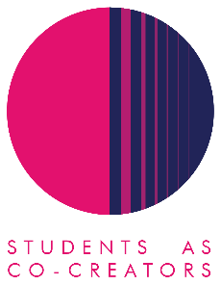
Students as Co-Creators Curriculum Design Collaborations (CDC) Application Form

The CDC strand of the Students as Co-Creators programme enables staff to work in partnership with students to develop an aspect of their course or module. Examples include:
- Learning materials
- Assessment guidelines
- Syllabus or assessment content
- Teaching style
- Blackboard
- Handbooks

We welcome all members of staff to apply for a CDC Students as Co-Creators project and recommend them to form a team with students prior to submitting an application. If staff are unable to recruit students, then the SCC team can try and pair members of staff with students from the Foundation years and above.

To apply, please answer all of the questions below and email the form to studentpartnership@westminster.ac.uk. For entry into cycle 1, you must submit your application by 12pm, 25th October 2019. Cycle 2 applications will close at 12pm, 5th February 2020. It is also possible to transition into cycle 2 after receiving ethics and budget approval in cycle 1 (see timeline below). Please refer to the Westminster Co-Creators Principles before you apply.

Name
Email
College/School | LASC (Westminster Law School)

- Which area of your curriculum are you interested in reviewing? Please tell us what you think will be involved in undertaking this review.
The broad area of focus of the review will be the law core foundation subjects on the LLB degree. Despite the diversity of our student body in the law school, these subjects are still taught through a white doctrinal approach. Through the review we will identify where this is a problem within learning materials and resources, teaching styles and assessment content.

- Why do you want this review to take place in partnership with students?
The pedagogical approach and learning materials in the law foundation subjects tend to be from a white hegemonic euro-centric perspective which is the norm in core modules on an LLB degree. This review will be a collaboration between staff and students in order to begin decolonising the core legal curriculum. The collaboration is essential since our student body is diverse and we need their views in order to begin introducing curriculum design. This will make the curriculum accessible and therefore the profession. Representation is important to students so they can identify and see themselves reflected in the legal profession.

- How do you propose to undertake this review? Please describe how you want to work with students.
Students and staff will work together to identify the areas of the legal curriculum that should benefit from decolonisation and diversification of teaching materials, methods and curriculum design (including assessment methods and content). We will do this through the following phases (after opening a call for student participants):

Phase 1: Brainstorming with the students: identification of the problems (with help from specialist facilitators such as Dr who is focusing on decolonising the curriculum at the University of Kent).
Phase 2: Focus Groups: taking key themes from the Phase 1 to explore further in smaller groups with students and specific questions.
Phase 3: Recommendation Report: using the discussions from Phase 1 and Phase 2, we will write a report recommending the key changes for development of decolonised learning materials and pedagogic strategy.

If you have confirmed with students that they would like to work in partnership with you, please provide their details:

Student Name
Student Email
College/School

Next Steps
A student and staff selection panel will meet to assess the applications and you will receive the outcome of your application via email by the 1st November 2019 for entry into Cycle 1 or 14th February 2020 for entry into Cycle 2. Once your application is successful, your team will be required to attend a mandatory introduction workshop.
Timeline
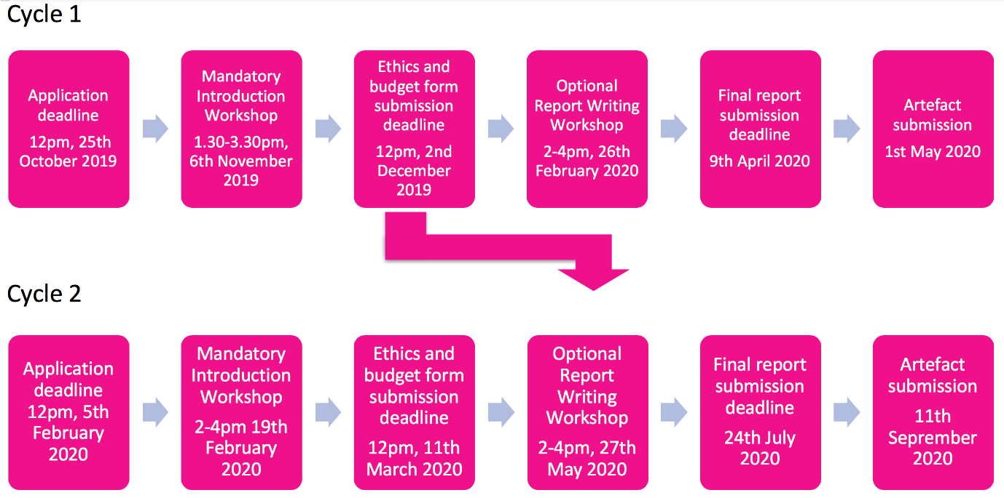
*If an ethics application is considered necessary, this may be submitted to the relevant School ethics committee or CTI ethics committee.
For further information and guidance on completing your application form please contact: Moonisah Bajwa Usman, Student Partnership Projects Co-ordinator, Centre for Education and Teaching Innovation, studentpartnership@westminster.ac.uk

