Project Title: YouTube and Mental Health

Research Team:

Trenton Lee, Christian Fuchs, Zubair Karmalkar, Carolina Lupanciuc, Dina Nazari, Amazonia Arroyo

University of Westminster School of Media and Communication

Academic Year 2018-2019

- Abstract

This exciting project explored the links between YouTube creators and mental health. YouTube, which first launched in 2005, is a platform that has allowed any of its users to create content and, if enough views are generated from said content, earn money from the advertising revenue generated through placing ads before, during and after user created content.
In order to be a creator that is able to make a living off of their uploaded content requires a lot of hard work and dedication. Over the last two years, more and more creators have spoken out about the high levels of stress that they experience as content creators for the platform, which has been coined by the mainstream media and “YouTube Burnout”. Burnout has been experienced in some form throughout the YouTube creator community and this research project, using survey analysis, was carried out in order to understand how posting videos on YouTube have an effect on mental health, specifically in regard to anxiety and depression level among YouTube creators. Our survey was circulated over a three-month period, launching one week before the first VidCon London 2019, a YouTube convention that is owned and operated by Viacom that sees hundreds of YouTube creators, viewers and industry professionals convene in one location. Our final sample size was n=36. Though this sample is not as big as we would have liked, the findings of this survey have highlighted some interesting trends in the relation between creating content on YouTube and self-reporting effects on anxiety and depression levels within the YouTube creator community. It is our hope that this research brings light to the mental health issues that stem from the pressures felt by creators to constantly create and launches a more in-depth analysis of this correlation in future studies of the community.

- Background and Aims
The main aim of this project was to establish and have an in-depth look at the effects of video blogging on the mental health of content creators. One of the things that inspired us to delve into researching this specific genre was the YouTube burnout experience that many content creators were facing. The fact that something as fun as creating videos for YouTube was turning into something that people were stressing over and feeling exhausted about was definitely of interest for us. Matt Lee is an example of a full time YouTuber, someone who made his big break after doing video game commentary.
He explained how excitement soon turned to anxiety as he struggled to keep up with audience demands such as consistency and felt that he couldn’t keep up with his schedule and felt his work was too rushed and harsh. He began to stress more about this and how it would ultimately make him lose his audience and his views, thus increasing the impact on his mental health. (Parkin, S, 2018, The Guardian).
The YouTube burnout also results in people making less videos or stopping altogether. In an article written by Sophie Bishop, she uses beauty vloggers as a case study, and she concludes that “YouTube’s algorithmic practices and published speculation contribute to stratification by class and gender on the video-sharing platform. The mobilization of viewing session algorithmic signals suggests that YouTubers who do not fit within an existing genre will be punished.” This does not however include channels that are outside popular genres and also demotes channels if users end a viewing session with a given video. (Bishop 2018). Therefore, the overall aim of the project was to find out whether more and more YouTuber’s feel their mental health is being heavily impacted or not and how it’s affecting their overall mood and motivation to carry on as content creators on this platform.

- Methods
The main methodology used for this project was survey research. Surveys consisted of yes or no questions, Likert scales and a final comment section that bluntly asks the participant “How has posting videos on YouTube had an effect on your mental health and well-being? Please describe the positives and/or negatives.” The questions that were the main focus of this research were asking participants to self-report their level of anxiety and depression both before and after they started creating videos on YouTube. It is recognized by our team that self-reporting of mental health issues (particularly the state of mental health in the past) is difficult to assure accuracy, but this measurement is very important to answering our central research question and we did not have access to the mental health records of our participants. We distributed the surveys online a week before the first VidCon to take place in London and we attended VidCon to get participants to take the survey. We would approach people and ask them whether they were content creators and then proceed to hand out a flier with instructions on how to fill out the survey online if they agreed to partake. Participants had the choice of filling the survey out in their own time or we would hand them a tablet if they wanted to do it straightaway. In the end, only 36 creators participated in taking the survey.

- Results + Discussion

Change in Anxiety
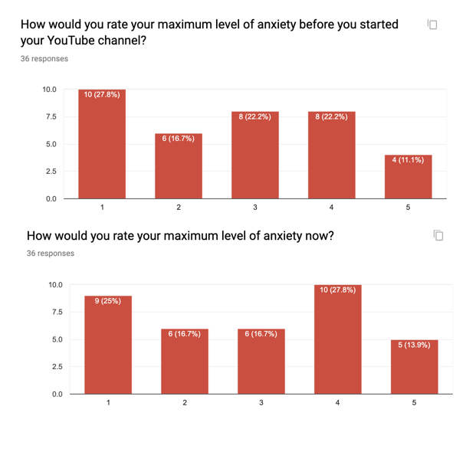
In terms of anxiety, within the YouTube creator community, we found that at least 69.4% of respondents have noticed a change in their level of anxiety from before to after they began to upload videos to YouTube. Of those who reported change, 64% reported lower anxiety levels, 12% of which reported significantly lower levels (-3 or more, e.g.. Before - 5; After - 2). YouTube is being used as a tool for creative expression but also personal development. The platform is a positive outlet for bringing communities together and spreading awareness. Some of the respondents compared posting videos to “therapy” that allows creators to express their selves on different topics and share personal struggles.

The other 30.6% that reported higher levels of anxiety, 20% of which reported significantly higher anxiety (+3 or more). In many cases, this anxiety was triggered by the psychological pressure that comes with the uncertainty of success and negative feedback in the comment sections below their videos. There’s an adaptation period for every single creator, frustration is a natural reaction but ultimately it is in their best interest to gradually learn and not give up.

We can see a double effect which impacts people. People respond differently to the pressure of constant content creation. Those who adapt well report an increase in confidence and self-development. Others relate their struggle with YouTube’s precarious, often misunderstood algorithmic system that controls who and how their content is viewed. The creative process can be healing and rewarding in many ways. Often times, creativity is not enough for more significant success, an inherent problem that ultimately becomes source of anxiety for YouTube creators.

Change in Depression

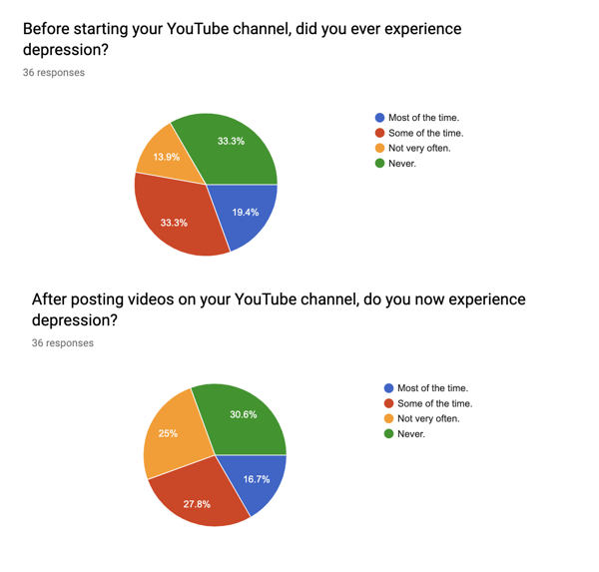

In their responses to our survey, 41.7% creators reported that they experienced a change in the number of depressive episodes from before to after they started posting videos on YouTube. Within this group, 33.3% of respondents reported an increase in depressive episodes, with 6.7% of those reporting a significant increase in the number of depressive episodes (+2 or more e.g. Before - Never; After - Some of the time). On the other hand, 66.7% of respondents reported a decrease in depressive episodes, with a 6.7% of those reporting a significant decrease in the number of depressive episodes (-2 or more).

The comments provided by candidates reporting with increased depression, provided a broad range of views, but overwhelmingly criticised YouTube’s inability to provide users with resources or services to treat depressive episodes triggered by using YouTube. One respondent said their channel felt more like a full-time job with a “disgruntled boss” - “I felt I was a store and I was part of the YouTube/Google sales team”.

Despite the feedback showing this consensus, another theme recorded from those who reported a decrease in depressive episodes is the general opinion of community and acquaintance generated between creators, with one respondent saying - “It is like therapy, I love having the opportunity of being creative”. Categorically, those who had never experienced depression before and after creating their YouTube channel reduced from 33.3% to 30.6%, indicating some increase in depression experienced has occurred in respondents after starting their YouTube channel. Similarly, those who experienced depression occasionally increased but the experience of depression after creating their channel increased from 13.9% to 25%. The fluctuation between responses of the categories: “Never” and “Some of the time” - (those who never experienced depression or experienced it occasionally) suggests that more people experience depressive episodes after creating their YouTube channel.

Change in Both

It was found that 83.3% of our respondents reported a change to either anxiety or depression. Out of these respondents, 30% reported a change to both anxiety and depression. 37.5% of those who reported a change to both reported an increase to both. 37.5% of the same group reported a decrease to both, while the rest had a mix. Below are the comments that corresponds to the two groups that reported the same change for both anxiety and depression. We wanted to highlight these two groups especially because we wanted to examine the reasons why the participants reported these changes. Below the comments we will discuss the themes that we pulled from the comments.

Both Increase (37.5%)

R13 – “I'm frickin' stressed. It's like having a boss that doesn't communicate anything to you and doesn't give you a set salary. You are always punished for not uploading, so I haven’tered really gotten a mental break from the platform for 3 years”.

R35 – “Stress from feeling ignored by Youtube. Dealing with Youtube Support is stressfull”.

Both Decrease (37.5%)

R11 – “It has definitely helped me come out of my shell more. I'm more open about speaking about my mental health issues. I feel happy when I see all the likes and positive comments, but I still get upset when I get a negative one”.

R30 – “Posting videos has made me a less anxious and less depressed person, it is like therapy... I keep myself busy so I don't have too much time to think on anything negative that might be milling about in my head”.

R31 – “I'm way more open to people and to the world and more confident. The editing aspect helped me to love myself better (voice, face...). It helped me put everything on perspective and take myself less seriously. On the other hand, when I was posting more regularly, I felt some pressure to please my subscribers. I sometimes feel like I'm not doing enough for my channel and feel guilty from time to time (less and less often)”.
Those who reported that both their anxiety and depression increased since starting to upload videos to YouTube mainly commented on how YouTube (the company) is like an uncaring “boss” and that they credit an increase in stress to the pressures put on them by the company to continuously create content with little to no support from YouTube. Those who reported that both their anxiety and depression decreased since starting to upload videos to YouTube mainly commented on how the process of creating content can be a form of therapy for them, making them more confident and helping them come out of their shell. It is important to note that most of the creators who reported an increase in stress and anxiety had higher subscriber counts than the average respondent to this survey, suggesting that as creators grow their audience, they feel more pressure to create and often feel like they are being neglected by the company they are creating content for.

- Conclusion

This research project set out to explore the correlation between uploading videos to YouTube and mental health issues, specifically around anxiety and depression. While we hypothesized that we would have seen more of an increase in both anxiety and depression, we discovered that there are more layers to unpack than just a simple correlation. There was a small trend that found that as the subscriber count for creators grew, there tended to be an increase in anxiety and depression levels, but this needs to be re-evaluated once again with a larger sample size. We found that those who reported an increase in anxiety or depression commented more on their discontent with YouTube as a company and that there is a lack of mental health resources provided by the company or they feel ignored or undervalued by the company. On the other hand, those who reported a decrease in anxiety or depression tended to comment more on the therapeutic quality of creating content for YouTube and the community element of the platform. We suggest that further research should be conducted with a larger sample size and more qualitative methods to really explore the experiences of creators and how their mental health either benefitted or suffered from the process of creating and sharing content on YouTube.

- Lessons Learned

This research was conformed for a group of five people in which each of us had a different role and task to do, the main outcome from this work experience was:

- Use WhatsApp groups to communicate important information or to transmit what we have to do relate to the research is not the most effective way.
- The motivation of all the members of the team was not the same, for that reason a more interesting incentive plan should be generated for the students. For example, instead of money, students can get some credits or co-creator program it could be taken as a part of the internship that students have to do.
- Make a work plan where everyone has equal participation from the beginning of the investigation is important.
- Knowing the skills and strengths of each team member is vital to be more effective in the project and will allow us to use human resources in a better way.
- Make a calendar of activities with the important dates for the project, it could help the organizational improvement of the team
- It was fascinated to have the opportunity to work with student from different backgrounds of bachelors because allow us to share skills and learn from each other.

- Research Group Reflection

The students as Co-Creators scheme was a valuable programme to be a part of, that also provided an insight into the work and rigour undertaken by researchers. The skills learned can be used by the students themselves in their own dissertations, future postgraduate courses or research in other ventures. The programme was especially useful for the second-year students whose theoretical module - Researching Media and Communication - largely occurred in tandem with the scheme, allowing for the students to utilise the theory learned in lectures, seminars and readings. The students also learned many things which could be applied to their own work and provided vital information that could use during their own dissertations, encouraging them to consider any future and viable subjects to analyse for this phase of their degree.

However, if the Students as Co-Creators scheme were to be replicated, there are a few recommendations that the students feel would benefit future cohorts. First, the introduction of such a scheme should be incorporated into an academic research module, for students in particular the massive incentive would be to earn a high mark in this module, thus their motivations would provide momentum towards research yielding greater results and improving efficiency of their work. Other parties would gain too, such as researchers and the University of Westminster who would need tasks completed and the promotion of their research, as well the university itself who would collate a vast contemporary bank of information for its own use.

In addition to this, the students feel that any workshops being held with academics should be made compulsory. Not only would it provide an opportunity to monitor progress of the programme and research, but also for academics to advise students on any queries, errors or other matters that would otherwise improve the efficiency and running of the scheme.

